1. 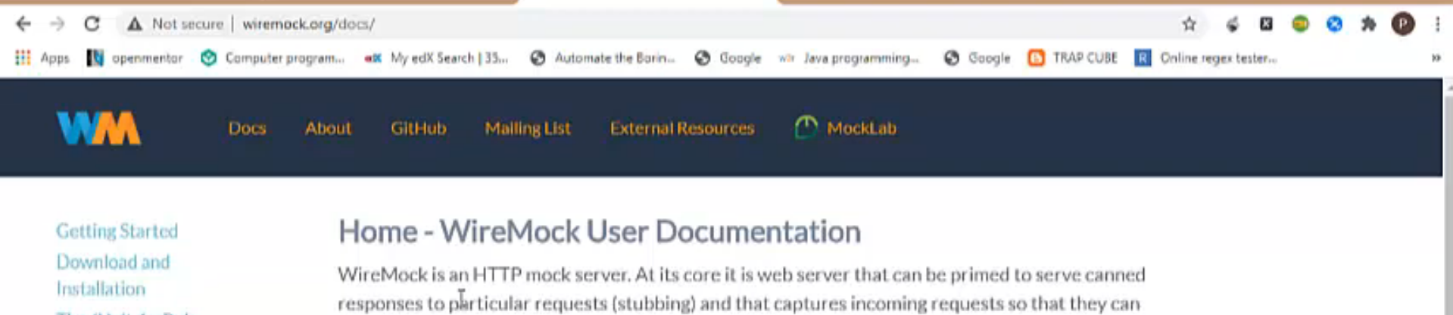
2. As we already know that WireMock can be run in two ways.
   1. Standalone.
   2. As a part of your Web App using Maven Dependency.
3. But we will be running it as standalone first as to understand the WireMock with respect to manual testing.   
   Then later on, we will see how to use it for Automated testing.
4. 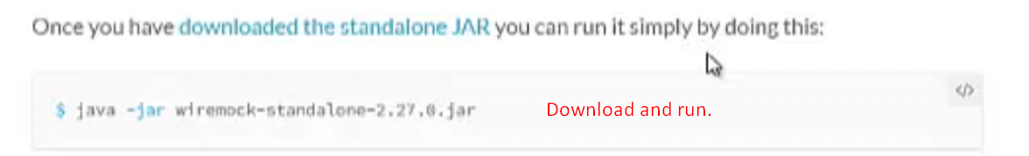
5. 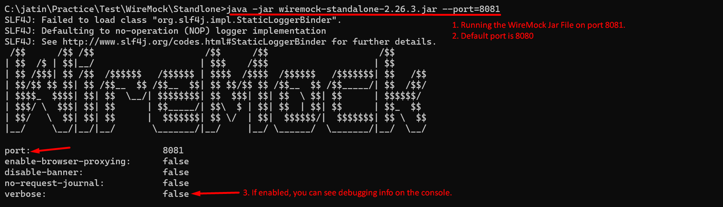  
   See as soon as we run the WireMock Server, we can see 2 files created alongside the jar file.   
   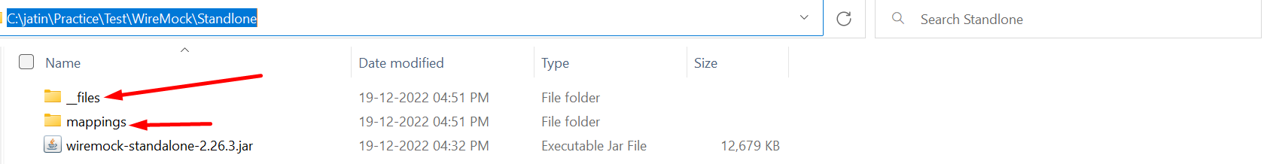
   1. **mappings**: Containing JSON files. One file for each stub (req + response)
   2. **__files**: This folder may contain files with response body only if we don’t want to store the response body in stub file under mappings folder.  
      Initially, both will be empty.
6. **Adding a stub**:  
   Graphical user interface, text

   Description automatically generated
7. **Let’s verify if stub is added**Graphical user interface, text, application

   Description automatically generated